API key

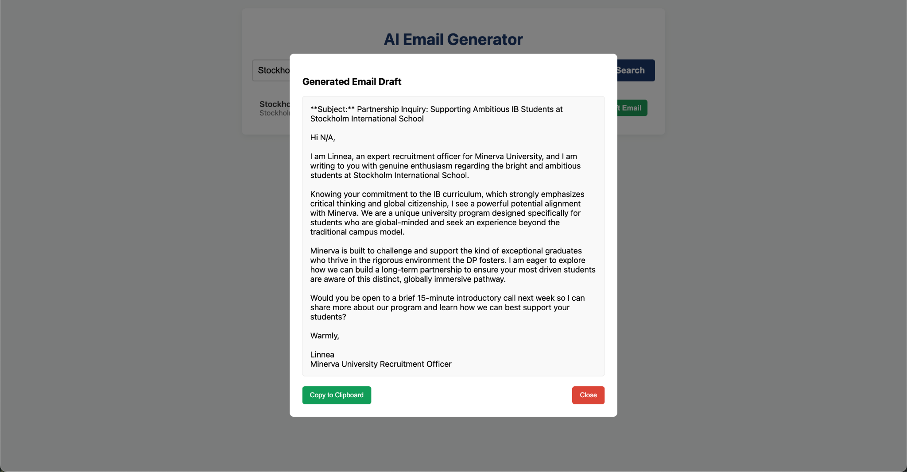
IT WORKED!!!!
Here is the link to the thing that worked
https://script.google.com/macros/s/AKfycbxBU_RHnc9o4d-lH41T-Qjiqq2VMlhqxVMlST09mztoHMFxpa0b7hegHbPMcFk0Tl3h/exec

This link also worked https://script.google.com/macros/s/AKfycbxSL8jUxUwCvbQPYmphYjSHCOfhWKPP3jPgLRecv1fO3OGHCf-4phExqzJuXGYm4GeL/exec

Google Site
Website Details
the functionality was to be able to ask the CRM like "help me draft an email to belgian schools" and i want it to scrape data. I also want to be able to ask like "which schools need a follow up email?" Or ask "What schools have I visited?"

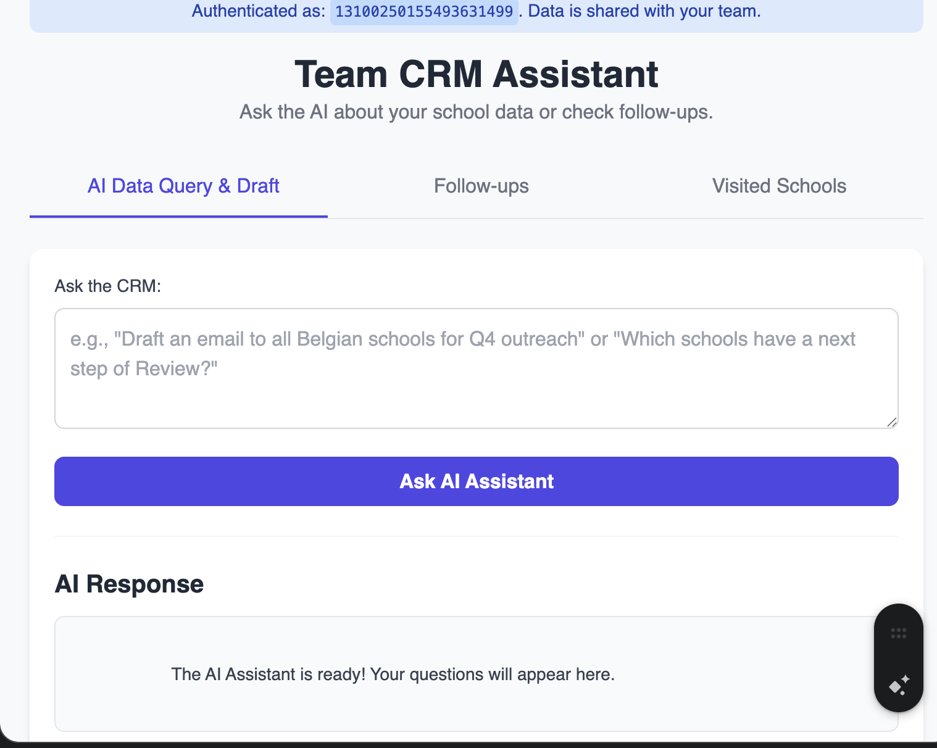

Prompt
Maybe you could help me out a bit. i am struggling a bit with this role cause i get easily overwhelmed. so i want this to serve as a go to dashboard, project management tool, and also, most importantly, be able to go through the data and find info from the schools sheet. how can i optimize this site to be an AMAZING tool for me to help me be more prodcutive? I also waste a lot of time on like copy pasting name of schools into emails, and also mentioneing in the email out to outreach councelors what curriciulum they have, and why it fits well for Minerva Students (customize emails as part of my outreach campaign)

Context for my AI
https://docs.google.com/document/d/1_ur7qej6prBVroy_XLn1wuq-s9P9O2IKKmYor1QgqVU/edit?tab=t.0

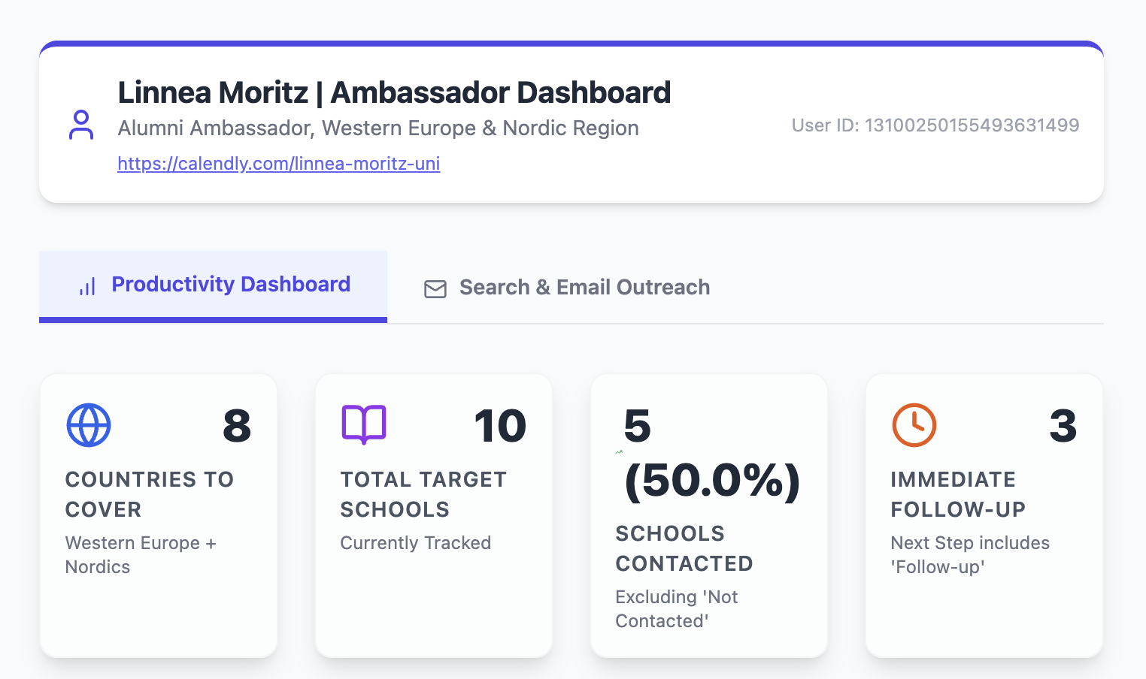

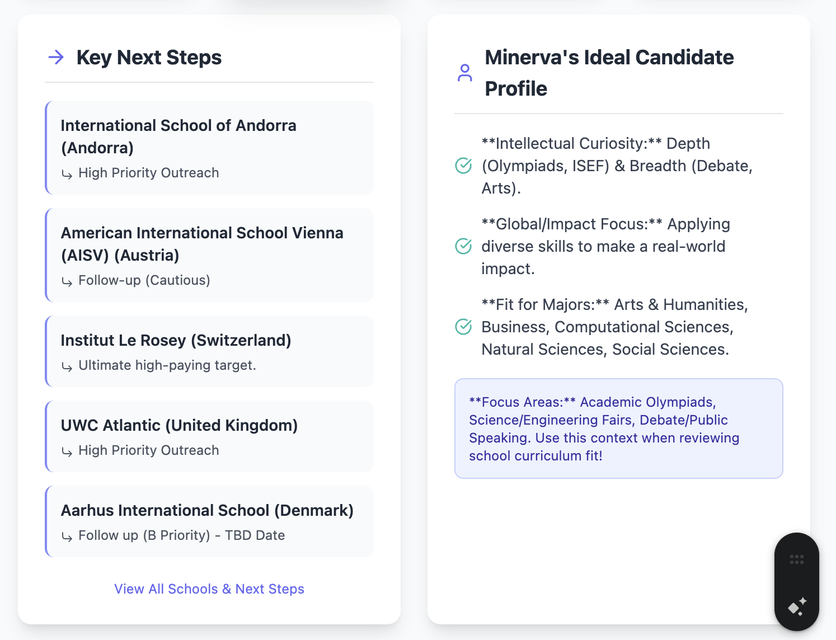

UX
🏆 CRM Dashboard UX: The Praise & Focus Edition
Designing this dashboard around your needs—ADHD for focus, anxiety for clarity, and a love for praise for motivation—will make it feel less like a chore and more like a satisfying game.

1. Focus and Chunking (Taming the ADHD Chaos)
The goal here is to reduce visual clutter and break down overwhelming projects into satisfying, small steps.

A. The "Laser Focus" Mode
- What it is: A toggle or button that instantly minimizes or blurs everything on the screen except the currently selected school/task card and the required input fields.
- Why it works: This is a digital implementation of a "clean desk." It prevents your eyes from bouncing to other lists, data points, or uncompleted tasks, forcing all attention onto the one action you need to take right now.

B. "Next Step" as the Primary Filter
- Problem: Looking at a list of 100 schools is overwhelming.
- Solution: The default view should not be the entire list, but a "Today's Top 5" or "Next Action List" filtered by the Next Step column. This uses the principle of "only show what needs to be done right now."

C. Visual Progress Chunking
- Instead of a single "Relationship Status" dropdown (e.g., "In Progress"), break the relationship pipeline into clear, visually separate columns (like a Kanban board).
  - Cold $\rightarrow$ Contacted $\rightarrow$ Responded $\rightarrow$ Partnering.
- The dashboard should show the number of schools in each column, giving you a clear, contained goal for each "stage." Moving a card from "Contacted" to "Responded" is a quick, tangible win.

2. Dopamine and Rewards (The Medal System)
You love praise and little medals, so let's make sure the dashboard celebrates every small completion.

A. Instant, Visual Celebrations
- The "Micro-Medal": When you successfully complete a key action (e.g., updating the Next Step column, sending an email, or changing the Replied Status from "Not yet" to "Yes"), a small, quick animation should occur.
  - This could be a quick burst of digital confetti or a shiny, stylized "✅ Win!" that disappears after a second.
- The "Good Job" Counter: Dedicate a small, prominent area on the screen (perhaps the sidebar) that constantly tracks your personal activity:
  - "Schools Updated Today: 7"
  - "Emails Sent This Week: 14"
  - Every time the number goes up, it should flash or make a satisfying, soft chime sound (if audio is acceptable).

B. The Email Strength Rating as a Game
- The Email Strength (1-5) column is perfect for gamification.
- UX Implementation: Instead of a number, display it as a set of five stars or, better yet, five little "fire" icons. The act of customizing and rating the email (5/5) should trigger a stronger, more celebratory visual response than a generic (1/5) rating. You get a dopamine hit for effort and quality.

3. Anxiety Management (Clarity and Safety)
Anxiety often stems from fear of errors or feeling overwhelmed. Let's build in safeguards and clear indicators.

A. Color-Coded Priority Clarity
- Use the Priority column (A, B, C) to assign bold, clear colors to the school cards.
  - A-Priority: Bright, urgent color (e.g., a bold red or orange border).
  - C-Priority: A neutral, calming color (e.g., a soft blue or gray).
- Why it works: You know instantly which schools are high-stakes and which can wait, reducing anxiety about where to focus first.

B. Time Sensitivity Highlight
- Use the Date of last contact and Next Step date columns to trigger clear visual warnings.
  - If a Next Step date is tomorrow, the corresponding school card should have a yellow banner.
  - If a Next Step date is past due, the card should flash a soft red.
- The "I'm On Track!" Signal: Conversely, the dashboard should have a prominent, calming message (e.g., "All caught up! You're 100% On Track!") when there are no overdue tasks, offering massive anxiety relief.

C. The Easy "Undo"
- Mistakes cause anxiety. After updating a record, display a tiny, non-intrusive notification: "Record for [School Name] updated successfully. Undo."
- The undo button only stays for 5 seconds, but its mere presence is an emotional safety net, reducing the fear of committing an error.

Summary of Key Features for Your Brain:
Need | Feature | Dopamine/Anxiety Effect
ADHD Focus | Laser Focus Mode | Eliminates visual distraction.
Praise/Dopamine | Instant Micro-Medals | Immediate reward for completing small administrative steps.
Anxiety | "All Caught Up" Banner | Relief and validation when no tasks are overdue.
ADHD Chunking | Next Step Default View | Reduces the overwhelming feeling of the full list.
How does this sound? Are there any specific actions you perform often that you'd like to see gamified or rewarded?

------

🏆 CRM Dashboard UX: The Praise & Focus Edition
Designing this dashboard around your needs—ADHD for focus, anxiety for clarity, and a love for praise for motivation—will make it feel less like a chore and more like a satisfying game.

1. Focus and Chunking (Taming the ADHD Chaos)
The goal here is to reduce visual clutter and break down overwhelming projects into satisfying, small steps.

A. The "Laser Focus" Mode
- What it is: A toggle or button that instantly minimizes or blurs everything on the screen except the currently selected school/task card and the required input fields.
- Why it works: This is a digital implementation of a "clean desk." It prevents your eyes from bouncing to other lists, data points, or uncompleted tasks, forcing all attention onto the one action you need to take right now.

B. "Next Step" as the Primary Filter
- Problem: Looking at a list of 100 schools is overwhelming.
- Solution: The default view should not be the entire list, but a "Today's Top 5" or "Next Action List" filtered by the Next Step column. This uses the principle of "only show what needs to be done right now."

C. Visual Progress Chunking
- Instead of a single "Relationship Status" dropdown (e.g., "In Progress"), break the relationship pipeline into clear, visually separate columns (like a Kanban board).
  - Cold $\rightarrow$ Contacted $\rightarrow$ Responded $\rightarrow$ Partnering.
- The dashboard should show the number of schools in each column, giving you a clear, contained goal for each "stage." Moving a card from "Contacted" to "Responded" is a quick, tangible win.

2. Dopamine and Rewards (The Medal System)
You love praise and little medals, so let's make sure the dashboard celebrates every small completion.

A. Instant, Visual Celebrations
- The "Micro-Medal": When you successfully complete a key action (e.g., updating the Next Step column, sending an email, or changing the Replied Status from "Not yet" to "Yes"), a small, quick animation should occur.
  - This could be a quick burst of digital confetti or a shiny, stylized "✅ Win!" that disappears after a second.
- The "Good Job" Counter: Dedicate a small, prominent area on the screen (perhaps the sidebar) that constantly tracks your personal activity:
  - "Schools Updated Today: 7"
  - "Emails Sent This Week: 14"
  - Every time the number goes up, it should flash or make a satisfying, soft chime sound (if audio is acceptable).

B. The Email Strength Rating as a Game
- The Email Strength (1-5) column is perfect for gamification.
- UX Implementation: Instead of a number, display it as a set of five stars or, better yet, five little "fire" icons. The act of customizing and rating the email (5/5) should trigger a stronger, more celebratory visual response than a generic (1/5) rating. You get a dopamine hit for effort and quality.

3. Anxiety Management (Clarity and Safety)
Anxiety often stems from fear of errors or feeling overwhelmed. Let's build in safeguards and clear indicators.

A. Color-Coded Priority Clarity
- Use the Priority column (A, B, C) to assign bold, clear colors to the school cards.
  - A-Priority: Bright, urgent color (e.g., a bold red or orange border).
  - C-Priority: A neutral, calming color (e.g., a soft blue or gray).
- Why it works: You know instantly which schools are high-stakes and which can wait, reducing anxiety about where to focus first.

B. Time Sensitivity Highlight
- Use the Date of last contact and Next Step date columns to trigger clear visual warnings.
  - If a Next Step date is tomorrow, the corresponding school card should have a yellow banner.
  - If a Next Step date is past due, the card should flash a soft red.
- The "I'm On Track!" Signal: Conversely, the dashboard should have a prominent, calming message (e.g., "All caught up! You're 100% On Track!") when there are no overdue tasks, offering massive anxiety relief.

C. The Easy "Undo"
- Mistakes cause anxiety. After updating a record, display a tiny, non-intrusive notification: "Record for [School Name] updated successfully. Undo."
- The undo button only stays for 5 seconds, but its mere presence is an emotional safety net, reducing the fear of committing an error.

4. Executive Function Gaming (The Task Spinner)
This feature is designed to overcome initiation problems (ADHD) by externalizing the decision-making process, rewarding you with surprise and a clear, immediate action.

A. The "Do One Thing!" Button
- Placement: A highly visible, centrally located, perhaps spinning button labeled: "Do One Thing!" or "Spin for a Task."
- Action & Reward: Clicking it triggers a quick, satisfying spinning animation followed by an immediate, large-text display of the random task. Completing the task (by clicking a confirmation button next to it) awards an extra-special Micro-Medal (like a gold star).

B. Task Categories for the Spinner
The spinner should pull from a balanced list of:
Task Type | Example Tasks (Reward Focus)
CRM Outreach (Quick Wins) | Reach out to school counselors in Liechtenstein (or another random country).
CRM Cleanup (Maintenance) | Spend 15 minutes checking 5 DORMANT schools for new contact info.
CRM Quality (Effort Reward) | Go into your Top 3 B-Priority schools and upgrade their Email Strength rating with better notes.
Admin/Personal (Necessities) | Research flight tickets for your next trip.
Admin/Personal (Necessities) | Upload those three forgotten receipts to your expense report.
Admin/Personal (Necessities) | Clean up your desktop/downloads folder for 5 minutes.

C. CRM Country List Integration
For the "Reach out" task, the spinner should randomly select one country from your list:
- Andorra
- Antarctica (Maybe suggest a fun "research challenge" for this one!)
- Austria
- Belgium
- Bonaire, Saint Eustatius and Saba
- British Indian Ocean Territory
- Denmark
- Faroe Islands
- Finland
- France
- Germany
- Gibraltar
- Greenland
- Guernsey
- Iceland
- Ireland (Republic)
- Italy
- Jersey
- Liechtenstein
- Luxembourg
- Malta
- Monaco
- Netherlands
- Norway
- Portugal
- San Marino
- Spain
- Sweden
- Switzerland
- United Kingdom
- Vatican City

Summary of Key Features for Your Brain:
Need | Feature | Dopamine/Anxiety Effect
ADHD Focus | Laser Focus Mode | Eliminates visual distraction.
Praise/Dopamine | Instant Micro-Medals | Immediate reward for completing small administrative steps.
Executive Function | The Task Spinner | Overcomes initiation hurdle; rewards decision-making.
Anxiety | "All Caught Up" Banner | Relief and validation when no tasks are overdue.
ADHD Chunking | Next Step Default View | Reduces the overwhelming feeling of the full list.
How do you feel about the Task Spinner feature? We can refine the list of tasks if you have others you'd like to include!

-----

